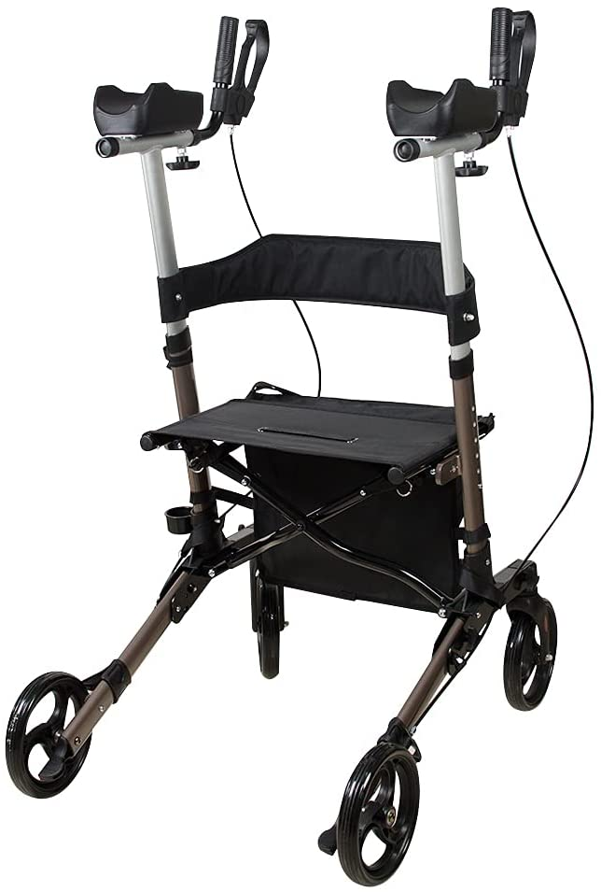

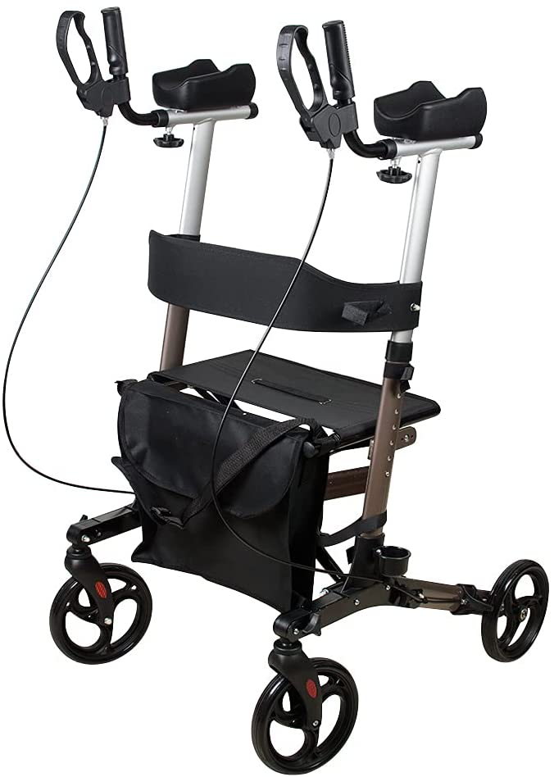 Specifications:
Width inside handgrips: 50cm/19.7”
Overall depth: 70cm/27.5”
Seat height: 54cm/21.3”
Weight: 8.4kg/18.7lbs
Overall width: 61.5cm/24.2”
Seat area: 46X25cm/18.1*9.84”
Adjustable handle height: 109-121cm/42.9-47.6”
Front / rear wheel: 8” (PVC) / 8” (PVC)
Max. user weight: 136kg/300lbs
Frame colour: Champagne

Five benefits of a forearm walker

- Reduces stress
- Decreases pain
- Provides safer mobility
- Walk further, walk longer
- Promotes user independence

Why use a forearm walker.
As people age, walking becomes more difficult because joints become stiffer, and muscle strength declines. Arm and wrist resilience weakens. Maintaining a good posture while walking grows more difficult. Ageing diminishes motor control and cognitive functioning. Aches and pains become chronic. A walker that can help keep the user in an upright walking position can prolong mobility and promote healthier outcomes.
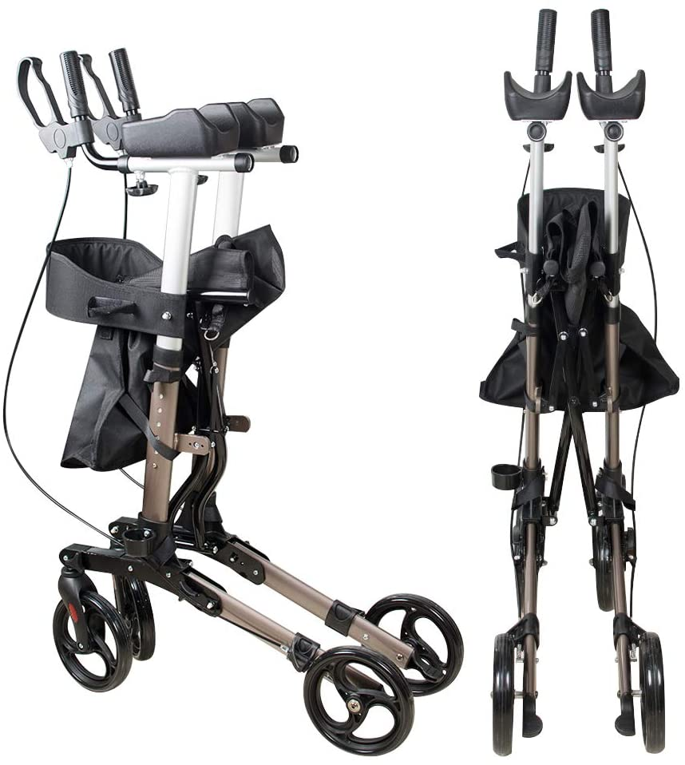 Dealers stamp here

