This stylish rollator is easy to fold with no adjustments to fold down for storage or transportation.
The fold down rollator is one of the most stylish and the easiest to fold on the market. It comes standard with the backrest and shopping bag. The fold down rollator is suitable for indoor or outdoor use and has a height adjustable ergonomical handle for comfort.
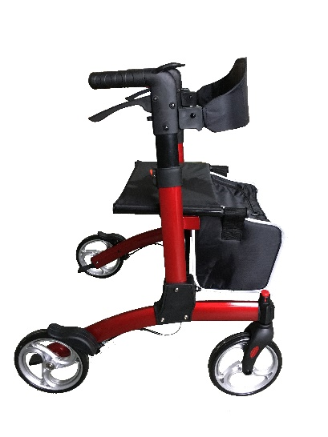

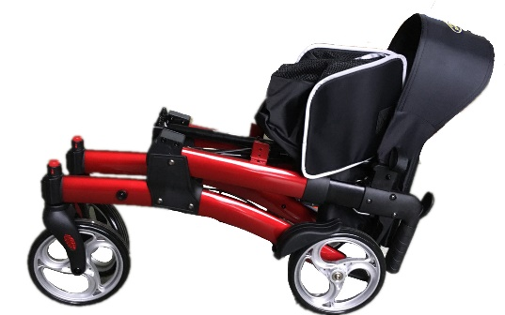 Specifications:
Width inside handgrips: 42cm/16.54”
Overall depth: 71.5cm/28.15”
Seat height: 54cm/21.3”
Weight: 8.4kg/18.7lbs
Overall width: 63cm/24.8”
Seat area: 45cmx25cm/17.72”x9.84”
Adjustable handle height: 80cm-90cm/31.5”-35.43”
Front / rear wheel: 8” / 8”
Max. user weight: 136kg/300lbs
Frame colour: Red
5 Top Features
- Quick release front castors
- Standard shopping bag and Backrest
- Lightweight stylish aluminium frame
- Liquid paint finish
- Easy to fold with no adjustments needed
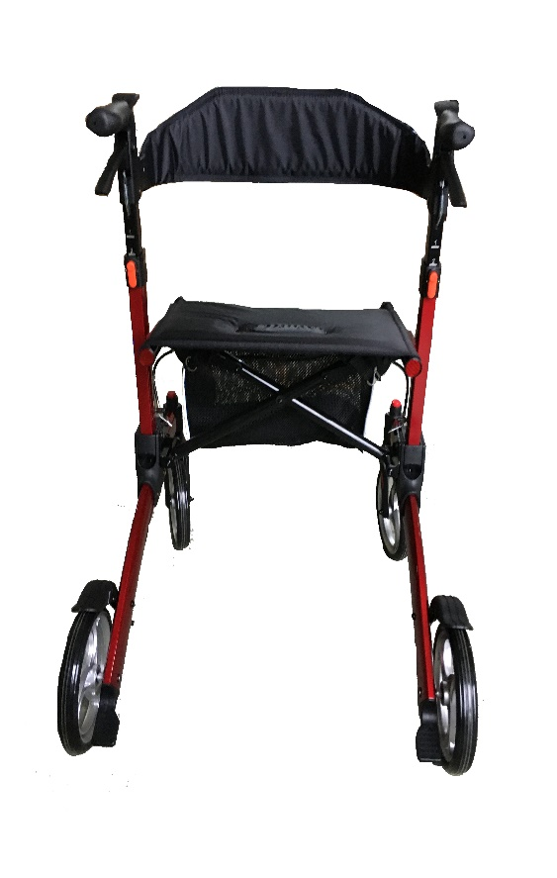 Dealers stamp here

