SUPERHEAD 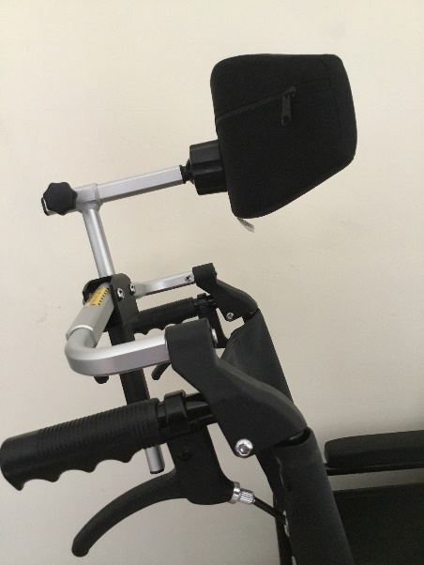
Features
Compatible with most manual and powerchairs.
Easy to mount: Only need to tighten 4 bolts.
Unique folding mechanism -system folds with the wheelchair and can be permanently fitted
Lightweight aluminium alloy frame.
Available in 4 sizes: 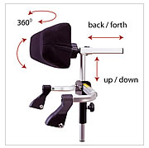
Size Adaptive to wheelchair seat width
Small: 300-360 mm
Medium: 360-460 mm
Large: 420-540 mm
X Large: 480-600 mm
The Superhead is intended for use as a comfort head support and is suitable for transportation.

